ELECTRICITY BILL GENERATION
DOMESTIC - SLAB SYSTEM
UNITS | UNIT PRICE
1-50 | 1.45
51-100 | 2.8
101-200 | 3.05
201-300 | 4.75
301-500 | 6.00
>500 | 6.25

30 UNITS: 30*1.45 = 43.5
80 UNITS: 50*1.45 + 30 *2.8 = 156.50
180 UNITS: 50*1.45 + 50*2.8 + 80*3.05=456.5
280 units = 50*1.45 + 50*2.8 + 100*3.05 + 80*4.75=897.5 380 = 50*1.45 + 50*2.8 + 100*3.05 + 100*4.75 + 80*6=1472.5
580 = 50*1.45 + 50*2.8 + 100*3.05 + 100*4.75 + 200*6 + 80*6.25=2692.5
#include<stdio.h>
#include<conio.h>
void main()
{
long serno, pre, cur, units;
char name[30];
float amt;
clrscr();
printf("Enter service no "); scanf("%ld",&serno); printf("Enter consumer name "); scanf("%s",name); printf("Enter previous month reading "); scanf("%ld",&pre); current:
printf("Enter current month reading "); scanf("%ld", &cur);
if( cur < pre ) { puts("\aCheck current month reading");goto current; }
units = cur - pre;
if(units<=50)amt=units*1.45;
else if(units<=100) amt=50*1.45+(units-50)*2.8; else if(units<=200)amt=50*1.45+50*2.8+(units-100)*3.05;
else if(units<=300)amt=50*1.45+50*2.8+100*3.05+(units 200)*4.75;
else
if(units<=500)amt=50*1.45+50*2.8+100*3.05+100*4.75+(units -300)*6;
else amt=50*1.45+50*2.8+100*3.05+100*4.75+200*6+(units 500)*6.25;
if(amt<67) amt=67;
printf("Amount=%.2f",amt);
getch();
}
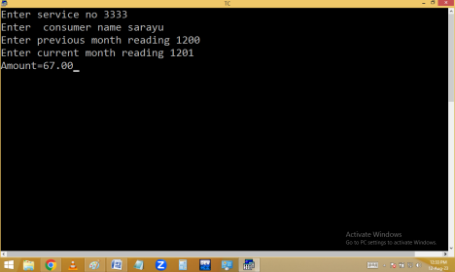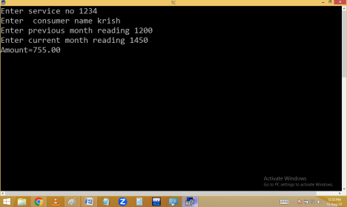
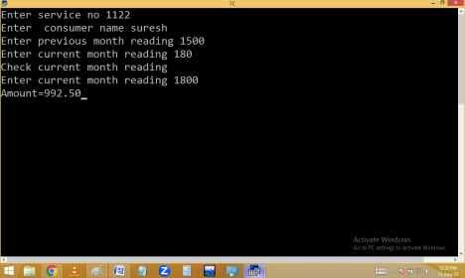Ternary / Conditional operator( ? : )
It is similar to if else / ladder if in working style.
It allows to complete if else / ladder if in a single statement.
When we are working with if else/ladder if it is going to take more than one line of
statements. Ternary operator is going to finish the same task in a single statement.
But the difference between if …else and ternary operator is ternary operator supports only one statement at a time and if supports any number of statements.
It is having 3 expressions. Hence it is called ternary operator.
It is starting with a condition. Hence it is called conditional operator.
Syntax:
condition ? true statement : false statement ;
exp1/op1 exp2/op2 exp3/op3
If condition true, statement after ? executed.
If condition false, statement after : is executed.
When compared with if else, conditional operator performance is high.
Eg:Finding big in two no’s using ternary operator.
